Bug_01:
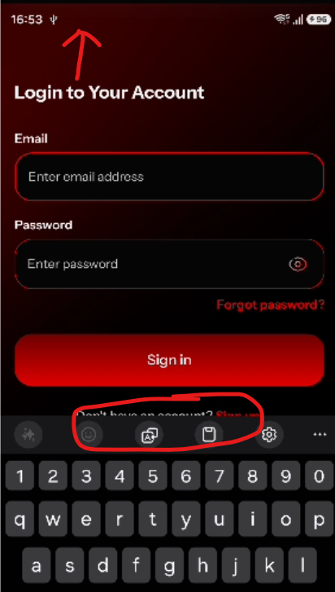
when keypad is open, the page should be move upward littlebit
Bug_02:
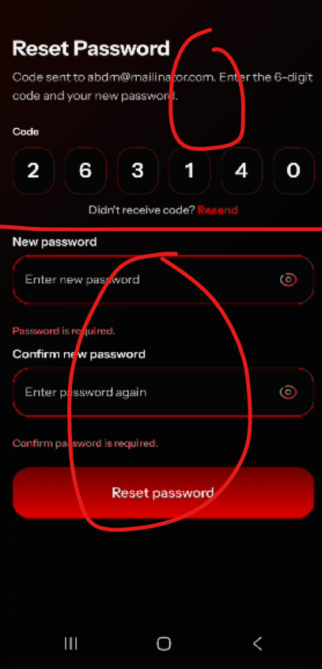
2 pages are required for these 2 sections.

Bug_03:
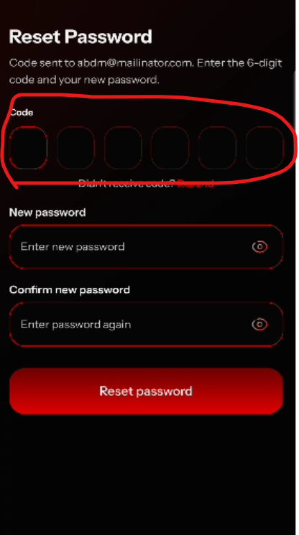
Keypad not open when click to enter code
Bug_04:
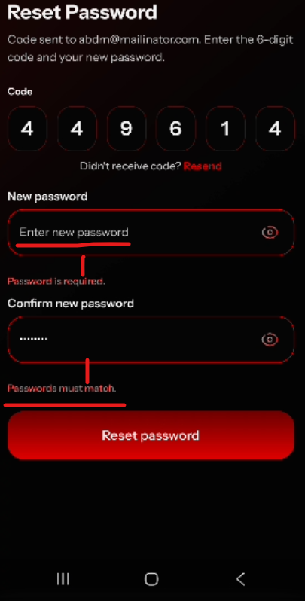
When password not enter, the confirm password field should be disable ?
password and confirm password error message should be little bit upward.

